

|  |
| --- |
| **Year 12 Mathematics Specialist 2017**  **Test Number 3: Vectors in 3 Dimensions**  **Resource Free** |

**Name: _______________________________________ Teacher: DDA**

**Marks: 29**

**Time Allowed: 30 minutes**

**Instructions:** You **ARE** **NOT** permitted any notes or calculator. Show your working where appropriate remembering you must show working for questions worth more than 2 marks.

_________________________________________________________________________

**Question 1** Circle the correct answer. **[1 marks]**

*M* (4, −1, −7) and which of the following points are on a line parallel with the *x*-axis?

**A** (−4, −1, −7)

**B** (3, −1, 7)

**C** (−4, 1, −7)

**D** (4, −1, 5)

**E** (4, 2, −7)

**Question 2 [3 marks]**

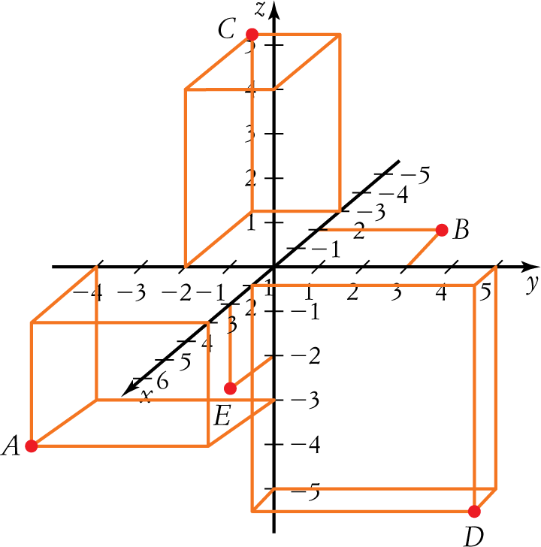

With reference to the above diagram, answer the following questions.

1. Which point lies on the x-y plane? _______
2. What are the coordinates of the point A? ___________
3. Find the exact distance from point D from the origin. ___________

**Question 3 [2 marks]**

Find a vector equation of the straight line which passes through the points (3*,* 7*,−*2) and (4*,* 5*,* −3).

**Question 4 [5 marks]**

A system of equations can have one unique, no or infinite solutions. The number of solutions for a system of equations having three unknown variables can be determined by understanding the following pattern occurring in a row of the augmented matrix in row echelon form.

0 0 # | #

0 0 0 | #

0 0 0 | 0

1. Identify which row indicates no solutions and show why.
2. Identify which row indicates infinite solutions and show why.
3. Given a system of equations with three unknown variables that has no solutions, a possible geometric explanation is that two or three of the planes represented by the equations are parallel as depicted in the images following.

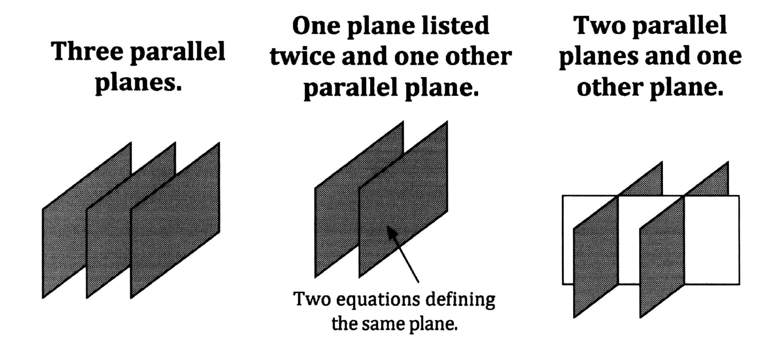

What other geometric possibility could explain no solutions.

**Question 5 [6 marks]**

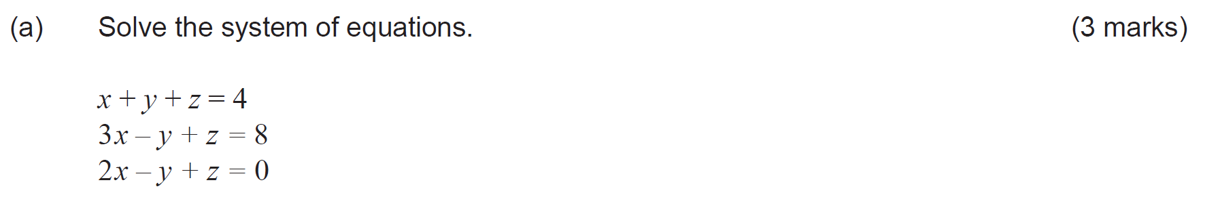

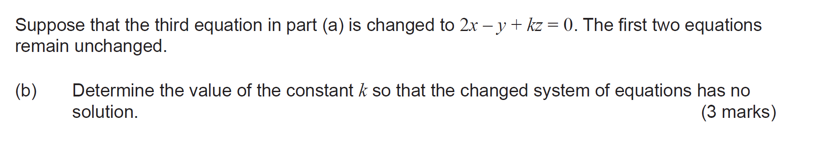

**Question 6 [7 marks]**

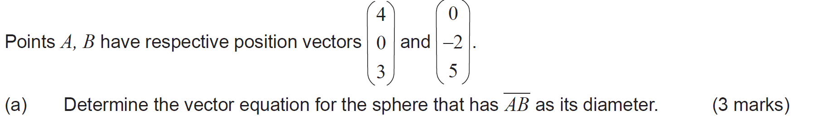

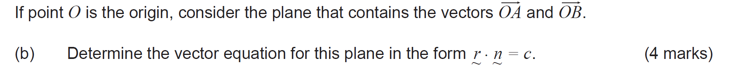

**Question 7 [3 marks]**

Given $a=<1,-1,1>$ and $a×b=<1,4,3>$, find a possible vector $b.$

**Question 8 [2 marks]**

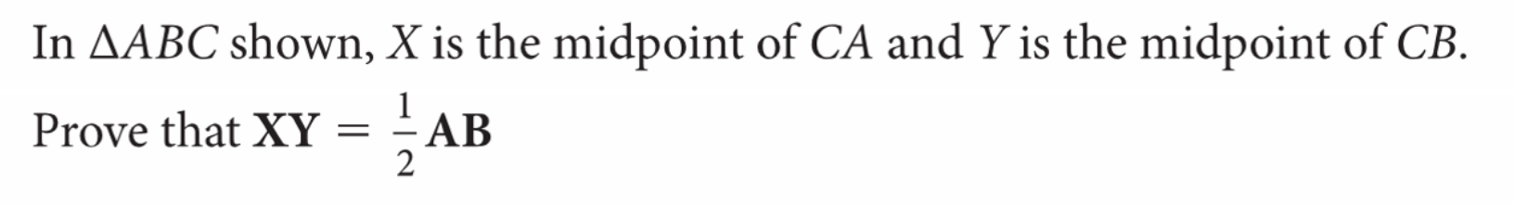 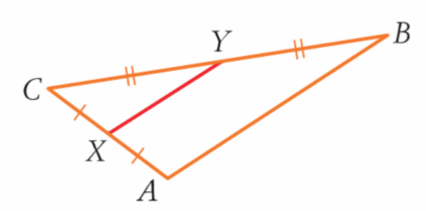

**[2 marks]**



|  |
| --- |
| **Year 12 Mathematics Specialist 2017**  **Test Number 3: Vectors in 3 Dimensions**  **Resource Rich** |

**Name: _______________________________________ Teacher: DDA**

**Marks: 17**

**Time Allowed: 15 minutes**

**Instructions:** You are permitted 1 A4 pages of notes and your calculators. Show your working where appropriate remembering you must show working for questions worth more than 2 marks.

_________________________________________________________________________

**Question 9 [3 mark]**

1. Find the magnitude of the vector product of vectors of magnitudes 15 and 9 if the angle between them is 75°.
2. Describe the direction of the vector product of the vectors in a).
3. Find the cross product of **u** = (3, −1, 5) and **v** = (−4, 2, −3).

**Question 10 [8 marks]**

An object moves such that its position vector $r$ m, at time $t$ s, is such that the velocity vector, $\dot{r}$ m/s, is given by $\dot{r}=\left[\begin{matrix}4\cos{2t} \\ 3\end{matrix}\right] \left(t>0\right).$

1. When $t=0$ the object has position vector vector $\left[\begin{matrix}2 \\ -1\end{matrix}\right]m$, with respect to the origin, O. Find the position vector of the object when $t=π$. [3 marks]
2. Find the speed and position vector of the object the first time, $t>0$, for which the velocity of the object is perpendicular to the acceleration of the object. [5 marks]

**Question 11 [4 marks]**

A disc with a radius of 12 cm turns with an angular velocity of 3 radians per second.

The position vector of a particle on the edge of this disc at time $t$ seconds is $r(t)$ m where

$$r\left(t\right)=0.12\cos{(3t)}i+0.12\sin{(3t)}$$

Show that $a\left(t\right)=-kr(t)$ for $k$ a positive scalar constant and determine its value.

What does the result $a\left(t\right)=-kr(t)$ mean in terms of the direction of $a$?

**Question 12 [2 marks]**

An object travels a distance of 35 m in 2.7 s as it moves around a circle of radius 2 m. Find, correct to 2 decimal places, the angular velocity, $ω$, and speed, $\left|v(t)\right|$, over that time period.

**Question 11 [7 marks]**